Final Project
Interviewee Approval
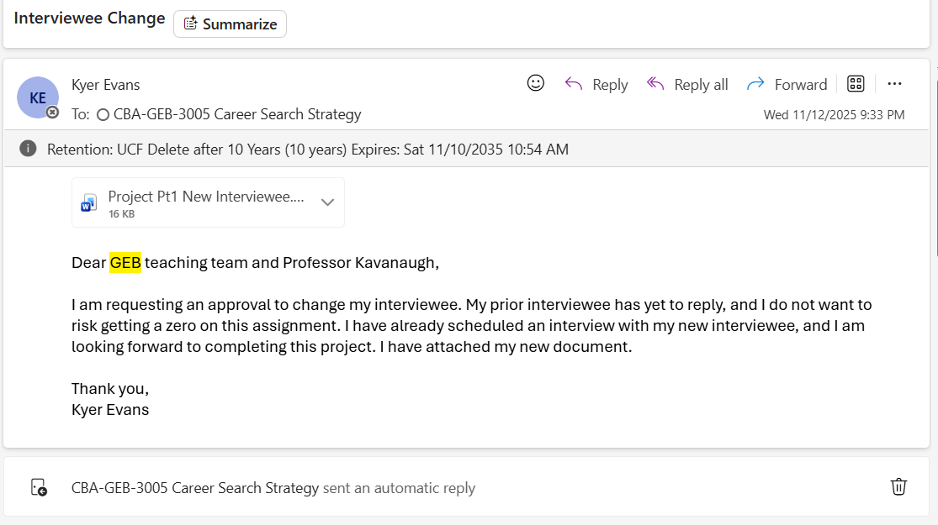

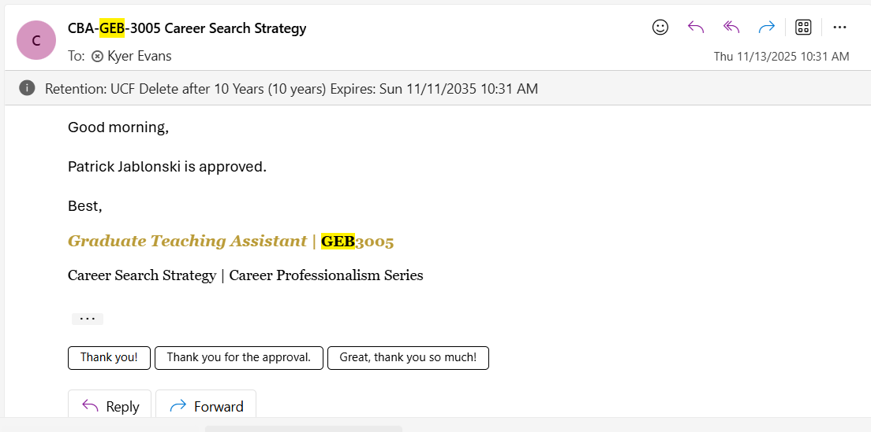

Linkedin:
(19) Patrick Jablonski | LinkedIn
Interview:
1. How did your competitive mindset from the NHL translate into your early success in medical sales?
Determination and will to win. When sales get hard people feel like they cannot get it done. Find ways to overcome hurdles. Summers can be especially slow as well as winter breaks, about 4 months out of the year are slower. People can create their own issues for themselves by getting comfortable. Keep your energy high and stay consistent. Never try to coast.

2. You’ve built long-term relationships with physicians for 17 years; what’s the biggest key to earning and keeping their trust?
Honesty, integrity. Solve their problems not your own. Make sure you put the customer first, always, even when it is hard. Never be transactional, keep relationships strong and lasting.

3. What was the moment in your first few years of medical sales where you realized, ‘I can really succeed in this industry’?
When I started closing deals and building relationships, I realized that I was passionate about helping people and building a long-term relationship rather than just sell them on something and move on. Building a rapport of repeat clients is better than trying to find new lead and clients all the time. It is a lot easier to make deals with people who already know and trust you and your work.

4. As someone who scaled a team from 5 to 30 reps, what qualities did you look for when hiring strong medical sales people?
Most people were athletes, fighters who want to succeed. Had a fire under their ass. Didn’t let NO bother them. Show that you’re willing to do whatever you can, be understanding, open to being trained.

5. Coming from the NHL, you’re used to high-pressure situations — what sales challenges in the medical world felt the most like ‘game-time’ moments?
When something goes wrong, upsets a client, I need to address the issues with customer. Lots of pressure. Especially big clients.

6. You opened 20+ new states and built new territories — what’s your process for entering and dominating a new market?
Once I get one client in an area I will develop the whole area, I also gain referrals from physicians, talk to reps to see how they can network. Talk to people who have the connections already, and offer to help them, because they can help you in return.

7. When you were overseeing national revenue growth and training programs, what strategic decisions moved the needle the most?
Medical billing company, most success came from finding competitors of our company and doing their billing for them, because that is our strong suit, and many companies are in need of better medical billing, so we essentially kill two birds with one stone, and it is a win-win scenario.

8. You’ve had nearly two decades of success — what habits or routines keep you performing consistently at a high level?
Routine, competitive edge, starting at a new company, using same principles, and being competitive. Don’t get comfortable, keep your momentum up. Communicating with your people, calling on the phone, not email, see what they need help with.

Self Reflection:
I met with Patrick through a zoom call. The meeting took place November 16th at 1:00pm. The meeting lasted roughly 28 minutes. My key take aways from our meeting was that in sales it is truly up to you to make yourself successful. No one is there to make sure you succeed, it all comes down to how badly you want it. I learned I need to be extremely passionate about my job and about building relationships with people. Having a large network of people is one of the best resources you can have because they can connect you with even more people. I was also inspired by a story Patrick told me about a single mother that he works with who was the most killer saleswomen ever. She was a true go-getter and high achiever because she had all the pressure of providing for her children on her own. Patrick said that having that mentality is what will get you the farthest, because when you are comfortable you are complacent and will not make anything great happen. I also learned that sales does not require very much education, it mostly comes down to your social skills, and being able to essentially become friends with the person you are trying to sell to. If you can develop that friendly relationship people are going to want to buy from you. I am definitely still interested in pursuing sales, however I do not think I am interested in medical sales, although it can be lucrative. Yes, this interview led to a discussion about Patrick’s time as a 20 year old playing professional hockey for my favorite team, the lightning. Patrick was the first goalie in lightning history, which is stinking awesome. We talked about how he still has connections with people in the NHL due to his strong ability to make lasting relationships. I did not provide tangibles, however we did talk about my interests as well as what I am involved in on campus. I did not bring things such as my resume to this zoom because I wanted to keep the focus on Patrick and get to hear all about his experience.

Screenshots of thank you follow up below.
